Step 1

Excel -> Tools -> Macro complémentaires in
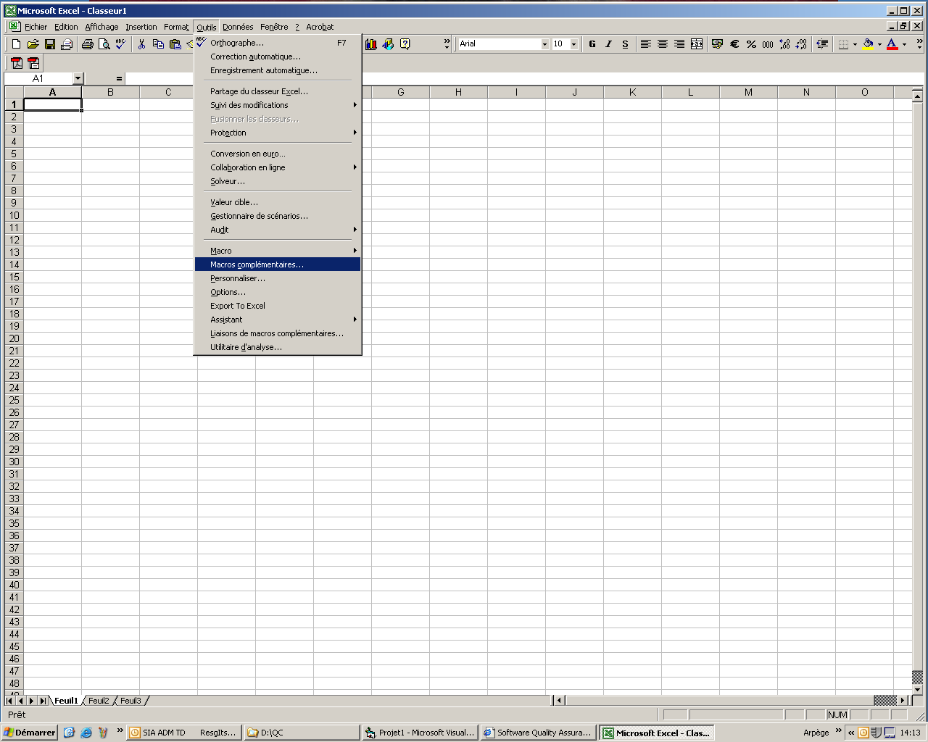

Step2 : Cliquer parcourir -> path to macro -> select macro -> OK

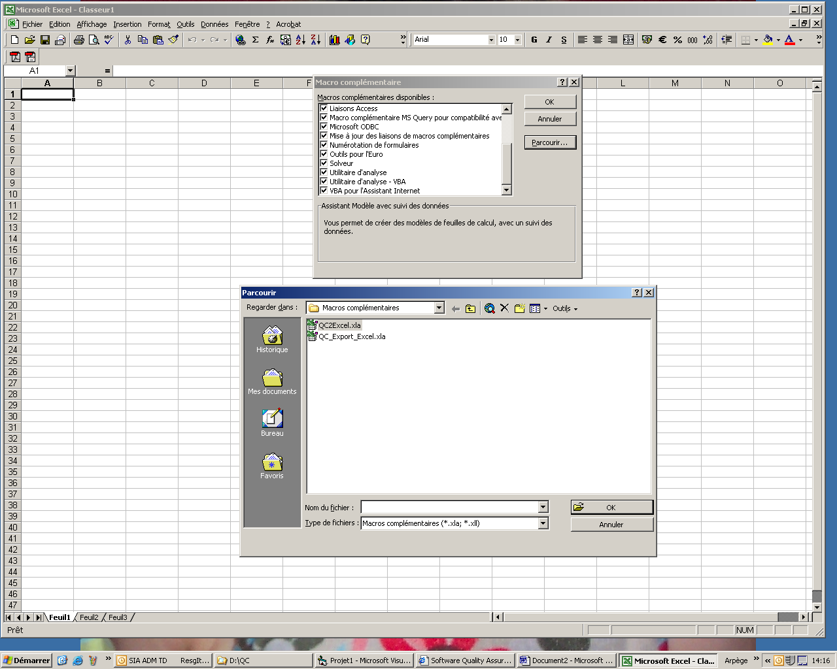

Step 3 Check Export to excel -> OK
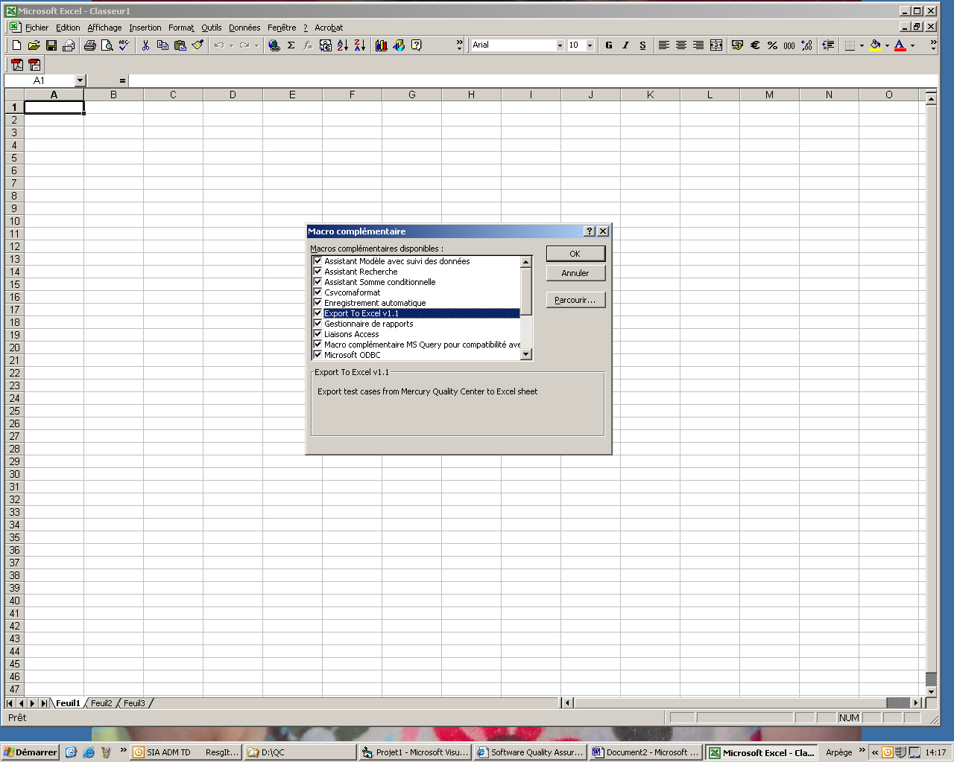

Step 4 : Tools -> Export to excel

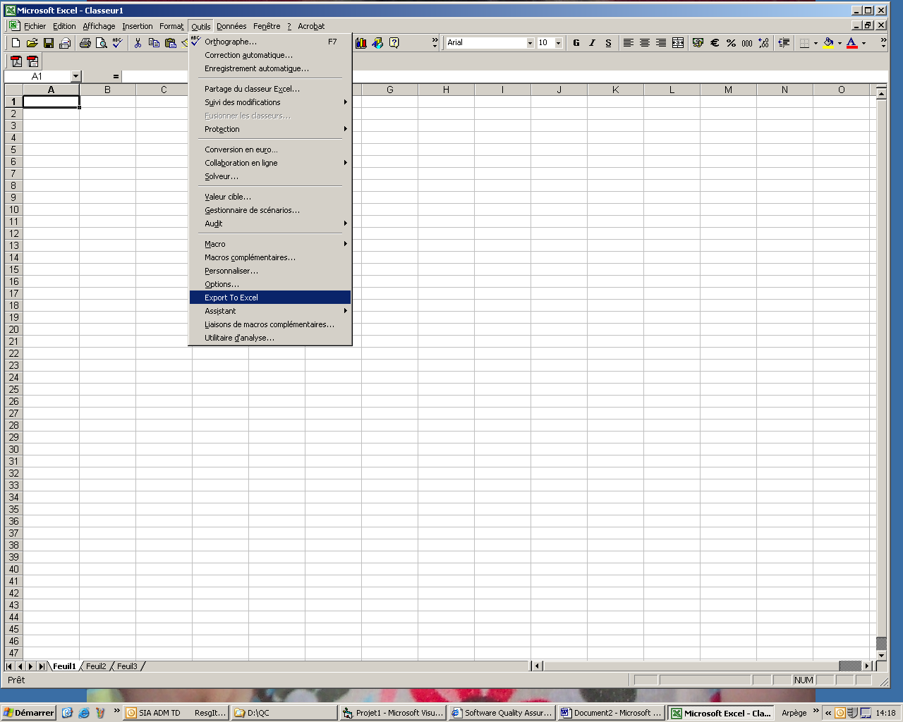

Step 5 : Enter QC server addresse .. et follow the next steps..

Good Luck

Syaman

